Mrs. Jacobsen Can Help!

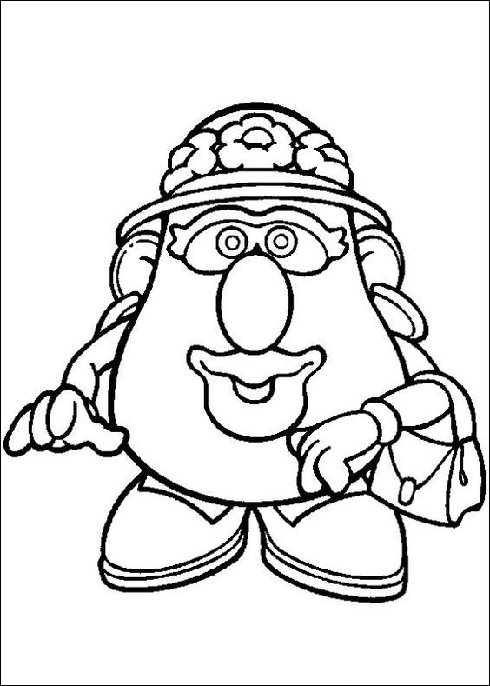
Mouth: Speaks kind words, but NEVER repeats what you say unless you are in danger of being hurt.
Mrs. Jacobsen is your school counselor. She can help you in all of these ways and many more! Tell your parent or teacher if you think you want to talk to me and they can assist you. I’m always happy to talk to you!
Color Me!
Eyes: Look out for students and see way to help students.
Bag of tricks to help you learn new skills.
Ears: to listen to you whenever you need someone to listen to your feelings.
Feet: Walk to your class, the playground or lunchroom.
Helping hands and arms for hugs!

